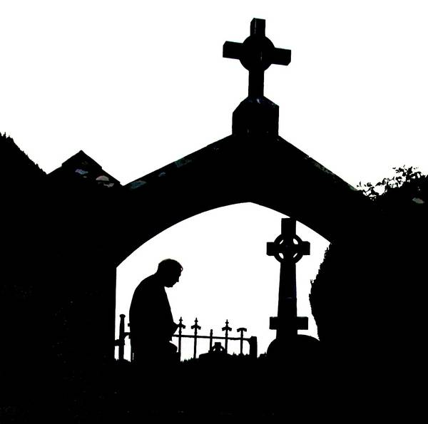 Patrun Sunday - Order of Liturgy
- Opening Hymn
- Priest’s Introduction
- Blessing of Water
- Opening Prayer
- Reading, followed by Psalm
- Reading, followed by Gospel Acclamation
- Gospel
- Reflection
- Blessing of Graves (accompanied by Rosary)
- Universal Prayer
- Optional Section
- Exposition of the Blessed Sacrament (accompanied by Tantum ergo)
- Prayer
- Blessing
- The Divine Praises
- Reposition (accompanied by hymn)
- Words of Thanks (if desired), followed by Concluding Prayer
- Opening Hymn
- Introduction
- In the name of the Father and of the Son and of the Holy Spirit.
- The grace of our Lord Jesus Christ and the love of God and the communion of the Holy Spirit be with you all.
The priest may now introduce the liturgy with a few words.
- Blessing of Water
Dear brothers and sisters, let us humbly beseech the Lord our God to bless this water he has created.
Almighty ever-living God,
who willed that through water, the fountain of life and the source of purification, even souls should be cleansed and receive the gift of eternal life;
be pleased, we pray, to bless this water,
which we use in confidence to implore forgiveness for sins and to obtain the protection of your grace against all illness and every snare of the enemy.
Grant, O Lord, in your mercy, that living waters may always spring up for our salvation, and so may we approach you with a pure heart
and avoid all danger to body and soul.
Through Christ our Lord. R. Amen.

- Opening Prayer
Lord God, as we gather here today, we commend all who are buried in this graveyard into your loving care.
As we remember them and their plight we pray that they may now rest in safety in the Kingdom of your love and peace, where every wrong is made right and there is no more suffering and pain, but peace and joy with Jesus and all the angels and saints.
We ask this through Christ our Lord. R. Amen.

- There now follows the Liturgy of the Word.

- The First Reading
- A reading from the Book of Numbers
The Lord spoke to Moses, saying: “Speak to Aaron and his sons, saying, ‘Thus you shall bless the Israelites: You shall say to them,
The Lord bless you and keep you;
the Lord make his face to shine upon you, and be gracious to you;
the Lord lift up his countenance upon you, and give you peace.’
So they shall put my name on the Israelites, and I will bless them.”
- The Word of the Lord.

- The Responsorial Psalm
- R: The Lord is my shepherd, there is nothing I shall want.
- The Lord is my shepherd, there is nothing I shall want.
Fresh and green are the pastures where he gives me repose.
Near restful waters he leads me
To revive my drooping spirit. R.

- He guides me along the right path, he is true to his name.
If I should walk in the valley of darkness no evil would I fear.
You are there with your crook and your staff
With these you give me comfort. R.

- You have prepared a banquet for me
In the sight of my foes.
My head you have anointed with oil.
My cup is overflowing. R.

- Surely goodness and kindness shall follow me
All the days of my life.
In the Lord’s own house shall I dwell
For ever and ever. R.

- The Second Reading
- A reading from the letter of St. Paul to the Romans
The life and death of each of us has its influence on others;
If we live, we live for the Lord; and if we die, we die for the Lord, so that alive or dead we belong to the Lord.
This explains why Christ both died and came to life; it was so that he might be the Lord both of the dead and of the living.
- The Word of the Lord.

- The Gospel Acclamation
Alleluia, alleluia!
Blessed are those who mourn
They shall be comforted.
Alleluia!

- The Gospel
- A reading from the holy Gospel according to Matthew
Jesus said,
“Come to me, all you that are weary and are carrying heavy burdens,
and I will give you rest.
Take my yoke upon you, and learn from me;
For I am gentle and humble in heart,
And you will find rest for your souls.
For my yoke is easy, and my burden is light.”
- The Gospel of the Lord.

There now follows a reflection by the priest.

- The Blessing of the Graves
The blessing of the graves now takes place and may be accompanied by the Rosary or other suitable prayers.

- Universal Prayer
Priest’s Introduction
God, the Almighty Father, raised his Son Jesus Christ from the dead; with confidence we ask him to save all his people, living and dead.
1. We pray for those buried in this cemetery
Lord Jesus Christ, the three days that you lay in the tomb made holy the graves of all who believe in you; and even though their bodies are laid in the earth, they know that they will rise again as you did. Give the bodies of our brothers and sisters peaceful rest in these graves, until that day when you, who are the resurrection and the life, will raise them up in glory. Lord, hear us…

2. We Pray for Our Family Members
Into your hands, O loving Father, we humbly entrust our family members. In this life you embraced them with tender love, deliver them from every evil and bid them eternal rest. Welcome them into Paradise where there will be no sorrow, no weeping nor pain, but the fullness of peace and joy with your Son and the Holy Spirit. Lord, hear us…

3. We Pray for Our Relatives and Friends
We pray for those who have gone before us, and await the Kingdom, that they may have the reward of their goodness. Lord, hear us…

4. We Pray for Priests, Religious Brothers and Sisters
Lord, look kindly on those whose life is now complete. Give them a place in your Kingdom and the fullness of your peace and joy in your heavenly liturgy. Lord, hear us…

5. We Pray for Those Who Mourn for the Loss of Their Loved Ones
May they find comfort in their sadness, certainty in their doubt, and courage in their loneliness. Make our faith strong through Christ our Lord. Lord, hear us…

6. We Pray for All Our Young People Who Have Died
We pray for our young who thirsted for life here on earth, may they now enjoy the fullness of life in heaven. Lord, hear us…

7. We Pray for Ourselves
For all who are assembled here to worship in faith, that we may be reunited one day with all whom we love, when every tear will be wiped away. Lord, hear us…

8. We Pray for All the Faithful Departed
and Those Who Have No One to Pray for Them
We pray for all who have fallen asleep in the hope of rising again, that they may see God face to face. Lord, hear us…

- Priest’s Conclusion
God, our shelter and our strength,
You listen in love to the cry of your people;
Hear the prayers we offer for our departed brothers and sisters.
Cleanse them of their sins
and grant them the fullness of redemption.
We ask this through Christ our Lord. R. Amen.

Two Options from Here:

A. If there now follows Exposition of the Blessed Sacrament, go to page 11.

B. If there is no Exposition of the Blessed Sacrament, go to page 13.

- Exposition of the Blessed Sacrament
- The Blessed Sacrament is now exposed in a monstrance placed on an altar with lighted candles.
- At the beginning of Exposition, the ‘Tantum Ergo’ is sung.
- The Blessed Sacrament is now incensed.
- A period of Adoration may now follow.
- After Adoration, the priest says:
Let us pray:
Lord Jesus Christ,
You gave us the Eucharist as the memorial of your suffering and death.
May our worship of this sacrament of your body and blood
help us to experience the salvation you won for us and the peace of the kingdom
where you live with the Father and the Holy Spirit,
one God, for ever and ever. R. Amen.
- The priest now puts on the cope and the humeral veil.
- He genuflects and then takes the monstrance in his veiled hands.
- He makes the sign of the cross over the people with the monstrance.
- A bell may be rung during this blessing.
- There now follow the Divine Praises.
- The Divine Praises
Blessed be God.
Blessed be His Holy Name.
Blessed be Jesus Christ, true God and true man.
Blessed be the name of Jesus.
Blessed be His Most Sacred Heart.
Blessed be His Most Precious Blood.
Blessed be Jesus in the Most Holy Sacrament of the Altar.
Blessed be the Holy Spirit, the paraclete.
Blessed be the great Mother of God, Mary most holy.
Blessed be her holy and Immaculate Conception.
Blessed be her glorious Assumption.
Blessed be the name of Mary, Virgin and Mother.
Blessed be Saint Joseph, her most chaste spouse.
Blessed be God in His angels and in His Saints.

- Reposition of the Blessed Sacrament, accompanied by a suitable hymn, now takes place.

- Words of Thanks
- The priest may now share some words of thanks.

- Concluding Prayer
Let us pray…
Lord God,
whose days are without end and whose mercies are beyond counting,
keep us mindful that life is short and the hour of death unknown.
Let your Spirit guide our days on earth in the ways of holiness and justice,
that we may serve you in union with the whole Church,
sure in faith, strong in hope, perfect in love.
And when our earthly journey is ended,
lead us rejoicing into your kingdom,
Where you live for ever and ever. R. Amen.

- The priest now departs.

