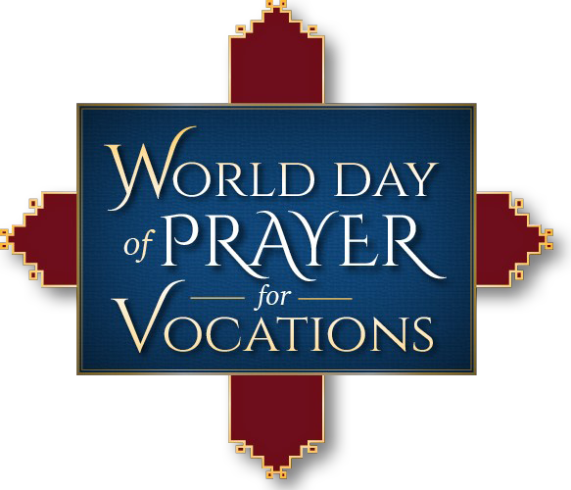
Resources for Priests/Parishes
Sunday 7 May 2017 · Good Shepherd Sunday
& World Day of Prayer for Vocations

Holy Father Urges Adoration for Vocations
“There can be no promotion of vocations or Christian
mission apart from constant contemplative prayer . .
above all, by the cultivation of a personal relationship
with the Lord in Eucharist adoration, the privileged
place for our encounter with God.” (Pope Francis’
Letter for 2017 World Day of Prayer for Vocations)
Consider holding a special Holy Hour for Vocations in
your parish.
Preaching on Vocations to Specific Audiences
It can be effective to address the “audience within the
audience” during your homily. Here are some ideas:
To children: God has a plan for your life! Boys —
don’t be afraid if He calls you to be a priest! Girls —
don’t be afraid if He calls you to religious life! After
all, Jesus wants us to be happy, so trust His call!
To teens and young adults: If you are not praying, you
cannot hear God’s call—simple as that. Likewise, if you
haven’t investigated all the various vocations, how can
you truly discern? Don’t just assume marriage is your
vocation.
To parents & grandparents: Let your kids (and grand-
kids know how proud of them you would be if they
became a priest or a sister. Let them know these are
viable and acceptable options for their life.

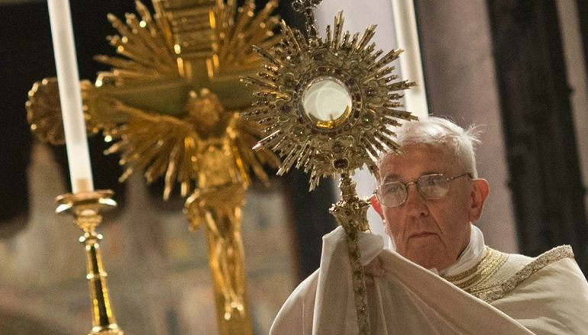
Homily Ideas | Sunday 7 May

First Reading: Acts 2:14, 36—41
Summary: Peter preaches to the crowd on Pente-
cost, exhorting them to be baptized and receive the
Holy Spirit.
When Peter addresses the crowd “they were cut the heart.” Sometimes the Holy Spirit speaks to us through a moment of clar-ity deep in our heart. Many men who have been called to the priesthood or women called to reli-gious life have had this experience — during Mass, on a retreat, or at a youth event. The question is, how do you respond? Will you be like those in the crowd that day, who responded wholeheartedly to the call?

Gospel: John 10:1—10
Summary: Jesus is the Good Shepherd. Those
who hear his voice follow him.
: To hear the Shepherd’s voice
requires quiet and prayer. Pope Saint John Paul II
said, “Young people, if they can be taught to pray,
can be trusted to know what to do with God’s call.”
Preach about prayer, methods of prayer, and the
importance of listening for God’s voice especially
when discerning the big decisions in life. All deci-
sions, especially our vocational calling, must be
discerned in the context of prayer. God has a spe-
cific vocation in mind for each of us and the only
way we can know God’s will is via prayer.
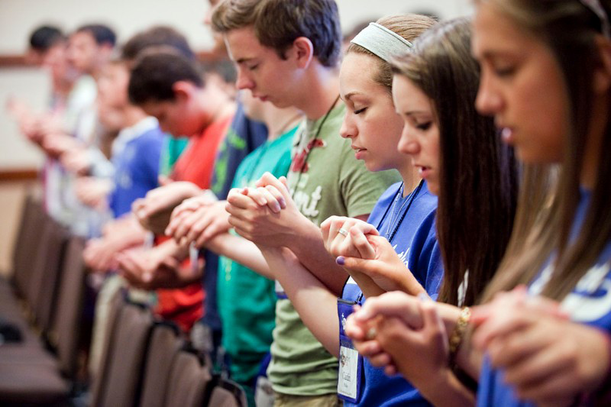
Prayers of the Faithful:
become priests. Let us pray to the Lord.
→ For those in our parish called to profess vows of

→ On this World Day of Prayer for Vocations, we
Church. Let us pray to the Lord.
→ That the example of religious sisters and broth-
salvation for the world. Let us pray to the Lord.
→ For all Catholics in the process of discerning
wisdom and peace. Let us pray to the Lord.
→ That God will call men from our own parish to
Realistic Ways Priests Can Encourage Vocations
From Fr. Brett Brannen, author of To Save a Thousand
Souls: A Guide to Discerning a Vocation to Diocesan Priest-
hood
• Every Thursday, the day Jesus instituted the Priesthood
at the Last Supper, I offer the votive Mass for priestly
vocations found in the Roman Missal. The people pray
with me specifically on that day for more priests.
• In my first parish, we used young men (18 to 25 or so) as
the Lord.

For the Parish Bulletin PaBulletin:
sacristans for the weekend Masses. Not only did this
greatly contribute to help with the liturgies, but it exposed
them to learning all about the Mass and gave them time
with the preists and all the lay ministers.
• When I visit a classroom to talk about vocations, I ask
the children, since they know one another so well, to tell
me who in their class they think would make a good
priest, brother, or sister. Amazingly, they always point to
one or two classmates. Rather than embarrass theose
students, I compliment them and invite them to pray
about this possibility.
• I will often ask a young man, “Do you want to be a
priest?” If he says no, I follow with: “If God asked you
to become a priest, would you do it then?” Almost eve-
ryone says yes. Then I tell the young man to pray and
ask the Lord: “Help me to want what you want for me.”
out the week.
• Encourage your children, grandchildren, or oth-
priest or religious brother or sister.
• Pray a rosary for more young men and women

→ That teachers and youth ministers will encour-
→ That parent will encourage their children to
• Pray for the priests who have ministered to you
Let us pray to the Lord.
→ For the deceased clergy and religious who have
2017 World Day of Prayer for Vocations
Today the Church throughout the world prays for
throughout your life, both living and dead.
• Keep our priests in your prayers through-
pray that God will supply holy shepherds for the
ers will show for the Church as the sacrament of
their vocation, that the Holy Spirit give them
poverty, chastity, and obedience. Let us pray to
the Lord.
age children and teens to respond to God’s call
to be priests and religious. Let us pray to the
Lord.
consider the priesthood and consecrated life.
vocations. Will you make a special effort to ask the
Lord for more vocations to the priesthood and reli-
gious life?
er young people to consider a vocation as a
in our diocese to respond to God’s call
served our parish, that the Good Shepherd will
welcome them with open arms. Let us pray to

