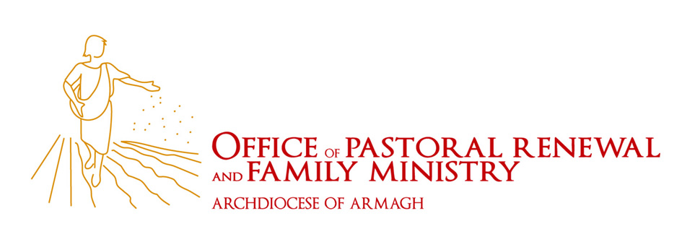

Thank you for registering for the Bible in a Day workshop. This one day, interactive workshop reveals the amazing story of salvation from Genesis to Jesus and the Church. The complexity of the Bible is made simple and easy to understand through a captivating narrative approach and the colour-coded Bible Timeline learning system created by Jeff Cavins.

You will gain greater understanding of your faith, the Mass, the sacraments, and a closer relationship to Christ!

The day will take place in Dromantine Conference Centre, Newry and together with participants from across our Diocese and other Dioceses you will learn about the Bible and how together we might encourage others to use this resource during Lent 2015 as a tool for deepening our faith and evangelising others.

NAME

EMAIL ADDRESS *

TELEPHONE NUMBER

PARISH/ORGANISATION

DIETARY REQUIREMENTS

ANY OTHER REQUIREMENTS

*confirmation will be by email only.

I enclose:

_____ £30 Early Bird Payment before 7th Feb. 2015

_____ £35 Payment after 7th Feb. 2015

Payment is non refundable

Please complete form and send with payment to:
OPRFM, Armagh Diocesan Pastoral Centre, The Magnet, The Demesne, Dundalk, Co. Louth

Cheques are made payable to: ‘OPRFM’

