
Armagh RE Community

Annual

REFLECTION DAY
June 2018

The Diocesan Advisers invite RE Teachers to a day of spiritual reflection led by: Fr Joseph Ralph OP & Team, Fr Paul Clayton Lee, Mrs Susan Morgan and Fr Declan.

Tuesday JUNE 19th in St John the Baptist College, Drumcree, Portadown.

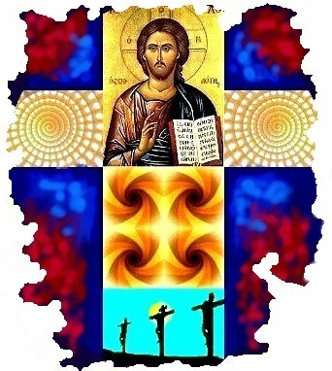
9.30 Arrival & Registration

10.00 Opening Session. Fr Joseph

11.00 Coffee Break

11.30 Second Session Fr Joseph

12.30 Light Lunch

- 30. Sharing Resources & Update.

2.00 In the Light of the Word. Fr Paul

3.00 Assessment, feedback and departure.

This is a time and space for you personally, take it as a call from the Lord to come aside from the rush and business of life and allow Him to give you rest and revitalise your spirit.

Please contact me with numbers and names of teachers
Complete and post back Form or email me

decoloughlin@yahoo.co.uk

