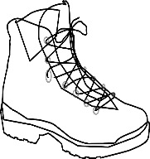
Pilgrimage Exhibition
- What is a pilgrimage? _____________________________________________________________________________________________________________________________________________
- What do you call someone who goes on a pilgrimage? _______________________________________________
- Give 3 reasons why someone might go on a pilgrimage: _____________________________________________________________________________________________________________________________________________
- Name 2 places in Ireland people may go on pilgrimage: ______________________________________________________________________________________________
- Name 3 other places people may go on pilgrimage: _____________________________________________________________________________________________________________________________________________
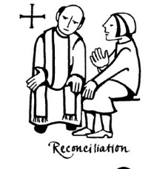
- List 5 things that you saw during the exhibition: ___________________________________________________________________________________________________________________________________________________________________________________________________________________________________________
- What questions do you have about pilgrimage after visiting the exhibition? (mention 3) ___________________________________________________________________________________________________________________________________________________________________________________________________________________________________________

